Image Processing With CUDA
Final report
Submitted for the MEng in
Computer Science for Games Programming
April 2024
by
Dawid Kisielewski
Word count: 10447

Abstract
Image processing is a field with a wide use of GPU acceleration. GPU’s parallel nature makes them perfect for doing computation on images as each thread can represent one pixel of the image. By exploring the implementations of different image processing techniques on both the CPU and GPU, allows for the collection of data of both implementations. Using this data, a comparison of both CPU and GPU can be done and the performance benefits of both can be analysed.
Contents
Abstract i
1 Introduction 3
1.1 Background to the project 3
1.2 Aims and objectives 3
1.2.1 Objective 1 – Research Image Processing Algorithms 3
1.2.2 Objective 2 – Creating CPU implementations 3
1.2.3 Objective 3 – Research GPU Architecture 3
1.2.4 Objective 4 – Creating GPU Implementation 3
1.2.5 Objective 5 – Compare CPU and GPU Performance 3
1.3 Research question 4
2 Literature review 5
2.1 Image Processing 5
2.1.1 Edge Detection 6
2.1.2 Image Segmentation 8
2.1.3 Noise Reduction 10
2.2 GPU 11
2.2.1 GPU Architecture 11
2.2.2 GPU Compute 11
2.3 Language Options and Libraries 12
2.3.1 Language 12
2.3.2 Lrbraries Error! Bookmark not defined.
2.4 Similar Studies Error! Bookmark not defined.
3 Requirements 14
3.1 Product requirements 14
3.2 Functional requirements 14
3.2.1 Interface 14
3.2.2 Algorithms 14
3.2.3 Benchmark 14
3.3 Design constraints 14
4 Design 15
4.1 Software design 15
4.2 Experimental design 15
4.2.1 Repeatability 15
4.2.2 Representability 15
4.2.3 Timing 15
4.2.4 Exporting Data 16
5 Implementation and testing 17
5.1 Implementation 17
5.1.1 OpenCV 17
5.1.2 Timing 18
5.1.3 Convolution 18
5.1.4 Sobel 19
5.1.5 K-Means 21
5.2 Testing 26
5.2.1 Sobel 26
5.2.2 K-Means 27
5.3 CUDA Optimisation 27
6 Evaluation of Data and Project 29
6.1 Results 29
6.2 Project Evaluation 32
7 Conclusion 33
References 34

Introduction

Background to the project
Image processing is the process of computing an image to enhance it or modify the image to ease the extraction of data from it. These processes can vary and accomplish different things, anything from removing grain and noise from images, segmenting the image into different sections to detecting and highlighting edges in the image as well as many other tasks.
Graphics Processing Units (GPUs) were originally created to accelerate graphics pipelines such as DirectX and Vulkan using hardware. Over the years they have gained thousands of more cores making them excellent at computing many tasks other than graphics calculations. Image processing algorithms are one of these tasks that have benefited from using the GPUs parallel nature to decrease the time taken for the algorithms to complete.
The are a few different APIs that allow you to write programs for the GPU. A few examples are CUDA, OpenCL, compute shaders in graphics APIs and many others. CUDA is a closed source API made by Nvidia for Nvidia GPUs, which means that programs created using CUDA can only execute on Nvidia GPUs. Recently there has been a translation layer created called ZLUDA that allow non-Nvidia GPUs to run the programs.

Aims and objectives

Objective 1 – Research Image Processing Algorithms
To research different image processing techniques and algorithms. This objective will allow me to research commonly used image processing algorithms as well as how they are implemented. By knowing the available algorithms, I will be able to select appropriate algorithms to implement for the purposes of studying the performance differences between the CPU and GPU.

Objective 2 – Creating CPU implementations
To implement the algorithms chosen in the first objective on the CPU. In order to compare performance differences between the CPU and GPU it requires the algorithms to exist on both CPU and GPU. This objective aims to create the selected algorithms on the CPU to be ready for comparison to the GPU implementations.

Objective 3 – Research GPU Architecture
To research GPU architectures and how computation is executed on it. By researching GPU architectures, more specifically the architectures of the GPUs which are going to be used to run the image processing techniques, this will help develop an understanding of how to write performant code on the GPU and how GPU programming is different from CPU programming.

Objective 4 – Creating GPU Implementation
To implement the algorithms on the GPU, which have already been implemented on the CPU. This objective will implement the algorithms chosen in the first objective on the GPU. To ensure that the GPU implementation is as performant as we can get it, we will be using Nsight compute.

Objective 5 – Compare CPU and GPU Performance
To compare performance metrics produced by running the algorithms with different sized images and parameters, we will be able to create graphs to analyse the differences between the performances. Using the knowledge gained from researching GPU architecture and comparing the results gained to the results of preexisting studies, this will allow us to come to a clearer conclusion.

Research question
“How does the performance of image processing Algorithms differ between running on the CPU and GPU?”

At the conclusion of this project the question of what the performance difference between image processing algorithms running on both the CPU and GPU will be found.
Using the current knowledge possessed, the prediction that GPU performance will be better than CPU performance can be made. The GPU will initially be less performant than the CPU but, due to the GPU being parallel its time complexity to complete the computations will be lesser. The CPUs performance will be constantly linear, where as the GPU will start of completely flat and then change to a linear line at a predictable.

Literature review

Image Processing
Image processing is the field of running computation on an image resulting in the image being modified to ease the process of extracting data from the image. There is a wide range of modifications that can occur to the image such as removing graininess and other noise, segmenting the image into different sections, detecting, and enhancing edges and many other modifications (Niblack, W. 1986)
Image processing is used in a wide range of applications. The most common application of image processing is noise reduction. All sensory equipment will have some sort of noise that will make it harder to use the data gathered, which also applies to digital image sensors. Images produced by these sensors will have some noise meaning noise reduction/suppression algorithms are used to remove some of the noise while reserving the actual image. (Alvi, F. 2023)
Another commonly used technique is edge detection which is the process of finding edges in an image. Usually the result of the algorithm is a black and white image where all the edges are shaded white and the rest of the image is black. Some algorithms display a gradient depending on how strong the edge is such as the Sobel operator (see section 2.1.1.1). A smaller set of algorithms display the direction of the edge using two colours. Edge detection can be used in many applications such as image stylisation, parts of computer vision pipeline and many others. (Encyclopaedia of Mathematics. 2011)
Image segmentation is another example of an image processing technique which is a vast field that encompasses a lot of different other techniques. The general purpose of segmentation is to separate different parts of an image from one another. An example of this could be separating different structures in an organ or to separate different parts of an image according to colour.
The techniques focused on will be edge detection, image segmentation and noise reduction. Figure 1 will be used to display the different effects the algorithms have on images.
Figure 1: An image widely used to test image processing algorithms. The image is of model Lena Forsén (https://imageprocessingplace.com/root_files_V3/image_databases.htm)

Edge Detection
There is a variety of different edge detecting algorithms. Classical approach for image processing will be discussed as more modern techniques involve neural networks and machine learning techniques that already leverage the power of the GPU. There are a handful of algorithms able to be studied which mainly use the method of convolution to produce a result. These algorithms are:
- Sobel
- Canny
- Roberts
- Prewitt

Sobel
The Sobel operator is one of the most common edge detection algorithms used, that runs on grayscale images using two separate convolutions. One convolution finds the horizontal edges and the other find the vertical edges. Both convolutions are 9x9 and are rotations of one another.
$G_{x}=\left[\begin{matrix}+1 & 0 & -1 \\ +2 & 0 & -2 \\ +1 & 0 & -1\end{matrix}\right]*I$ $G_{y}= \left[\begin{matrix}+1 & +2 & +1 \\ 0 & 0 & 0 \\ -1 & -2 & -1\end{matrix}\right]*I$
$G_{x}$ is the convolution of the kernel for the vertical edges and the $G_{y}$ is the convolution of the kernel for horizontal edges. These kernels are run for every pixel resulting with two separate images each containing separate edge directions. The magnitude is then found using the two directions calculated previously using the Pythagorean theorem followed by normalizing it. The resulting value is the edge intensity and can be set to the output pixel.
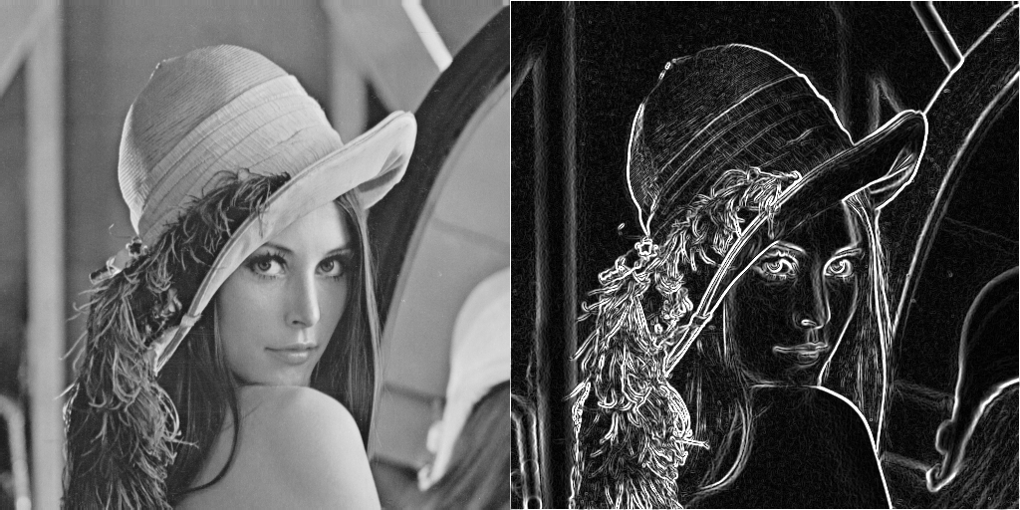
Figure 2: The original image (Left) and the result of the Sobel (Right) (Generated using my implementation)
As seen from figure 2 the output result shows a gradient across an edge, where the brighter the pixel appears the stronger the edge is in that location.
A useful side effect of calculating the vertical and horizontal edges separately means that the angle of the edge can be calculated and displayed in colour. There are quite a few applications where this function is used, such as artistic uses of the difference of gaussians (Winnemoller H. 2012).

Canny
The Canny edge detector gets its name from John F. Canny who created it. The edge detector starts of by preforming the same steps as a Sobel i.e. it uses the two kernels to find horizontal and vertical edges, then it finds the direction of the edge as well as the gradient (the edge). After performing these steps it continues on to perform two additional steps that result in a cleaner and more usable result.
After the Sobel operator, it finds the centre of each edge changing the image from an image with a gradient over the edges, to an image where all the edges are a single pixel wide. This is possible due to the ability of the Sobel operator to calculate the direction of the edge meaning that it is possible look at the pixel values across the edge and find the strongest value across the gradient. The pixel with the greatest value will be set as the centre of the edge and the rest of the pixels across the edge will be set to black. The last step in the process is to find the edges that which are prominent in the image and not a slight change in the colour of an object or noise. To do this hysteresis thresholding is performed, which requires two additional parameters to be entered to complete. These parameters are a lower bound and an upper bound. The first step in the threshold is to discard all the pixels under the lower bound entered. Next, it marks all the pixels at or above the upper bound. Finaly, it travels along the edges of each strong edge, as found from the previous step, and marks all the pixels in between the bounds as strong edges and all the pixels that are not connected to any strong edges are discarded. This process of steps ensures that only the strongest and most prominent edges in the image is displayed as well as the edges exact position.
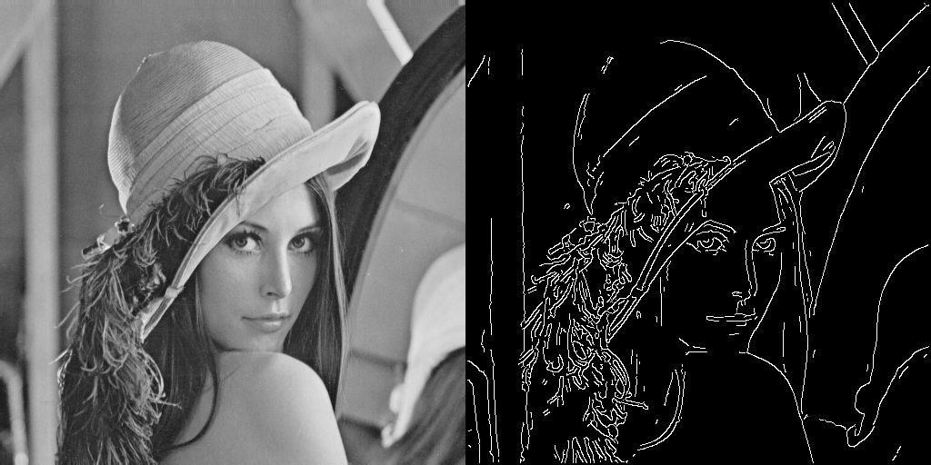
Figure 3: The original image (Left) and the result of the Canny edge detector (Right) (Generated using MATLAB)
As seen from Figure 3 the result of the Canny edge detector produces a more precise result compared to the Sobel operator shown in Figure 2. This is not true for most applications as each time a new image is used the lower and upper bound of the hysteresis threshold needs to be adjusted for the result to be usable.

Roberts
The Roberts edge detector (also known as the Roberts cross) is a convolution filter similar to the Sobel operator where it also uses two kernels and has the ability to find the direction of the edge. Unlike the Sobel operator, the Roberts does not find horizontal and vertical edges, instead it finds edges going diagonally.
$G_{x}=\left[\begin{matrix}+1 & 0 \\ 0 & -1\end{matrix}\right]*I$ $G_{y}=\left[\begin{matrix}0 & +1 \\ -1 & 0\end{matrix}\right]*I$
The Robers cross uses two 2x2 kernels. $G_{x}$ calculates the intensity of the edge in one diagonal and $G_{y}$that does the same but in the opposite diagonal. After this step the magnitude is calculated using the Pythagorean theorem with the resulting image being similar to the result of a Sobel operator, except it’s a lot dimmer and it doesn’t capture as many edges as the Sobel does. It is also more liable to noise.

Prewitt
The Prewitt operator works exactly the same way as the Sobel operator. The only difference between the two operators is the kernels they use. The Prewitt operator use the following kernels:
$G_{x}=\left[\begin{matrix}+1 & 0 & -1 \\ +1 & 0 & -1 \\ +1 & 0 & -1\end{matrix}\right]*I$ $G_{y}= \left[\begin{matrix}+1 & +1 & +1 \\ 0 & 0 & 0 \\ -1 & -1 & -1\end{matrix}\right]*I$
As you can see the only difference between the Prewitt and the Sobel operators’ kernels are the waits from the closest neighbour across the edge. This means that the resulting image is extremely close to the Sobel result.

Edge Detector Conclusion
All edge detectors on display in this section are well documented and have uses in real life but for the purpose of this study only one will be implemented. The edge detector which is going to be implemented will be the Sobel operator. This is due to a few reasons, notably the Sobel operator is the most commonly used algorithm other than the Canny edge detector. Compared with the Canny edge detector, the Sobel operator is much easier to implement. With the time constraint this has been a large factor in this decision.

Image Segmentation
“Image segmentation is the process of dividing an image into meaningful regions” (Niblack W. 1986). These sections depend on the algorithm used and desired result. For example, an image of an organ could be separated into different structures inside of it using colours. It could also be used to separate different objects from within an image. Segmentation algorithms use a lot of different techniques such as machine learning and neural networks, but others use typical logical processing techniques.
There are two types of image segmentation, semantic and instance. Semantic segmentation is the simplest as it only looks at individual pixels and determine if those specific pixels should be grouped together. Instance segmentation looks at the overall picture and finds the boundary of an object.
The segmentation techniques discussed will be:
- Thresholding
- K-Means

Thresholding
Thresholding is one of the simplest and most commonly used image segmentation techniques. This technique always returns a binary image (an image containing only two colours), usually black and white. The simplest version of this algorithm takes a threshold parameter which is checked against every pixel in the image. If the pixel is below the threshold its value is set to black, otherwise the value of the pixel is set to white. This is the simplest form of image segmentation as it only requires one if statement to be run on every pixel value (Niblack W. 1986).
It is also possible to have a variable threshold. This involves this formula:
$$t=kσ\left(i,j\right)+\overline{v(i,j)}$$
In this formula $t$ is the threshold value, $k$ is an arbitrary value (for the purposes of this study 0.18 will be use similarly as to Wayne Niblack’s book on image processing where the technique is described), $σ\left(i,j\right)$ is the standard deviation of the pixel and its neighbours, and $\overline{v(i,j)}$ is the mean value of the pixel and its neighbours.
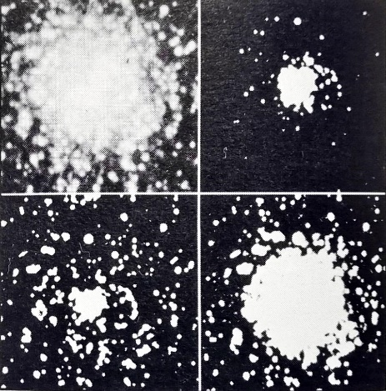
Figure 4: From top left going clock wise, The original image of a cluster of stars, the image with a hight threshold, the image with a low threshold, the image with a varying threshold (Niblack W. 1986)
Figure 4 shows the difference between having a static threshold and an adaptive threshold. The original image shows a cluster of many stars where the stars in the middle of the image merge together and appear brighter than the ones on the edge of the image. With a high threshold most of the stars around the edge of the image are culled and only the stars in the centre remain. With a low threshold all that remains from the stars in the centre is a blob meaning nothing can be comprehended from it. With the varying threshold all the stars on the edges are preserved and most of the stars in the centre of the image are more distinct.
Thresholding also can be done on coloured images. This process is referred to as colour thresholding and involves plotting all pixels on a graph based on colour and setting parameters that represent lines that split the pixels on the graph. This would result in an image with n number of coloured segmented.

K-Means
K-means is an unsupervised machine learning clustering algorithm. Machine learning is the process of an application gradually improving on its accuracy over time learning. This being an unsupervised machine learning model means that human input isn’t required to teach the program for it to improve. Clustering is the act of grouping object together in a way where objects in one group have more in common with each other compared to objects in other groups. All this in combination means that k-means clustering is an algorithm that learns improves itself to eventually group objects (Dhanachandra N. 2015).
K-means clustering can be used to segment an image. K-means is a semantic segmentation technique as it doesn’t understand/recognise any objects in the image but rather tries to group pixels into k number of colours. This process is also called pixel quantization which is the general process of reducing the number of colours in an image. The result of the k-means cluster always results in a different result as the machine learning process.
K-means clustering requires 2 parameters, the number of clusters and the number of times the algorithm will iterate. When working with coloured images it is important to think of the image as a 3d graph where each axis represents red, green, and blue (this is reduced to 1d graph if grayscale and 2d if only 2 colours are taken into account) and every pixel is placed somewhere on the graph. There are 2 parts of the k-means algorithm, assignment and update. First, the algorithm randomly place k number of “means” on the graph. Next, the algorithm iterate over the assignment step followed by the update step as specified by the iteration parameter. In the assignment step the distance between all the pixels and the means and each pixel is assigned to the mean closes to them. In the update step each groups mean is moved to its centroid (the mean position of the group). By repeating these steps the means will move towards large clusters and find pixels that are similarly coloured. At the end of the algorithm the colour of every pixel is set to the colour the group mean it is in. this results in a image with k number of colours (Dhanachandra N. 2015).
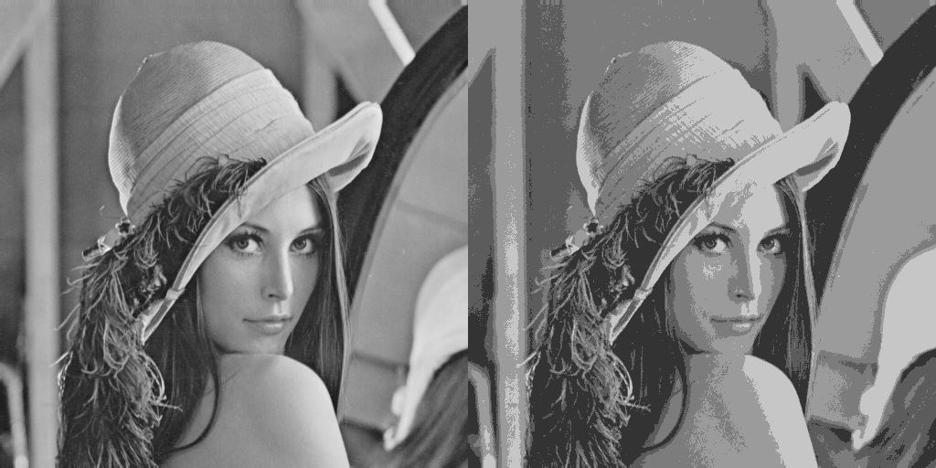
Figure 5: The original image (left), the image quantized with 5 colours using 10 iterations (generated from implementation)
As seen in figure 5, the k-means successfully selects 5 appropriate colours to quantize the image with only 10 iterations. This technique is quite useful to reduce the colours in an image to either accentuate the features in an image or, to compress the image by reducing the colours present in the image.

Noise Reduction
Noise Reduction and image restoration is a heavily used process that you see everywhere. Almost every image taken in the modern day from phone cameras and medical imagery machines. Especially in the field of medical imagery noise reduction and image restoration are very important as scans using radiation use low doses resulting in an image with a lesser resolution and fainter features causing the image to be more prone to artifacts and noise.
There are two main types of noise reduction algorithms, edge preserving and non edge preserving. These refer to the same edges as in the edge detection section. Edge preserving algorithms ensure that the edges in the image stay as strong not to blur the lines between different sections in the image. Non edge preserving filters often act as blues and reduce all detail in images. An example of this would be a box bluer that averages out a pixel’s colour with its neighbours.

GPU
Graphical processing Units (GPUs) are a specialized piece of hardware designed to make the rendering of 3D graphics faster and more streamline. Graphics rendering is well suited for parallel tasks meaning that the GPU is highly parallel. This means that the GPU is efficient for tasks that involve a lot of the same calculation performed multiple times on different sets of data, but highly inefficient at complicated sequential logical processes that the CPU preforms.
GPUs can trace back to early 70s home video game console which contain specialised chips (often called Picture Processing Units or Video Interface Chips). These chips were designed to process video to be able to be displayed on screen. At the time home computers would not have been able to display images/videos and would only be able to display characters from the machines code page (a file containing all the characters the computer can display) (Singer G. 2023).

GPU Architecture
GPUs are designed to run in parallel meaning they have thousands of cores compared to CPU which typically have single digit core counts. The process of running programs using CUDA involves a large number of steps before actual code is run on the GPU as well as after the GPU program has concluded. When using CUDA the CPU and the GPU are referred to as the host and the device respectively. This is because all programs start by running on the CPU and then initiating GPU methods. These individual methods are referred to as kernels.
CUDA architecture has 3 basic structures which help the programmer utilise the full capability of the GPU. This architecture is splits into the grid, the block and the thread. The grid is comprised of a 2 dimensional arrangement of blocks. Each CUDA kernel contain one grid. This means all the threads that run a kernel are contained in the one grid. The block is a logical unit containing a number of coordinated threads. All blocks in a grid run the same program and have built-in variables blockIdx and blockDim to help identify the position of the block. A GPU typically contains 65535 blocks. The block is comprised of a 3 dimensional arrangement of threads. Threads run on individual multiprocessors and have an inbuilt variable called threadIdx which can identify a thread relative to its block. There are typically 512 threads in a block (Ghorpade J. 2012).
There are six types of memory when programming in CUDA. The first type is global memory which is the slowest. This memory is un-cached and can be accessed by every block. Next is texture memory, which can only store 2D texture data. Next is constant memory this memory only stores constant values relating to the grids and blocks arrangements. Next is shared memory which is common among all threads in a single block. Next is local memory which stores local variables that are not cached. Local variables allow for atomic reads and writes. Lastly is the register memory. This final type is used for cached values that are often read by a thread such as counters (Ghorpade J. 2012).
These systems allow the programmer to optimise algorithms to utilise a greater potential of the GPU. By using better optimised and faster memory where appropriate the programmer can increase compute speed. By using more appropriate block and grid arrangements it is possible to increase GPU occupancy to better utilise the GPU.

GPU Compute
Before the 2000s GPUs could not be programmed on, with the only way to use the hardware was with the graphics API that were available. This changed with the advent of programable shaders which are programs written to be run on the GPU to calculate the positions of vertices, the lighting and the colour of every pixel. The first GPUs with programable shaders were the GeForce 3 series of GPUs from Nvidia in 2001. These shaders are written in a graphics language such as High Level Shader Language (HLSL) and OpenGL Shader Language (GLSL). These languages were designed to make graphics programming easy and not to do general tasks like compute. They do not have the same types and data structures that are present in typical programming languages such as C++ and C#.
Tasks such as image processing running on the GPU have a special name; General Purpose compute on the Graphics Processing Unit (GPGPU). These sorts of programs running on the GPU would have been written using HLSL or GLSL and use their respective graphics API. This changed when Nvidia released Compute Unified Device Architecture (CUDA), which was the first API that allowed programming of the GPU using already existing programming languages. CUDA requires the GPU running the code to have CUDA cores which only Nvidia GPUs contain. This means that all CUDA programs can only run on Nvidia GPUs. Soon after the release of CUDA both Microsoft (creators of DirectX) and Khronos Group (the organisation in charge of OpenGL) made similar APIs called DirectCompute and OpenCL respectively (Ghorpade J. 2012).
For this project an API/Language needed to be chosen to be use. Due to only having access to Nvidia GPUs, CUDA was chosen. Nvidia GPUS allows us to set up and use CUDA with ease making it easy to set up. Unlike DirectCompute, OpenCL and shader languages, CUDA allows us to have native support allowing the development of the algorithms to be both simpler and efficient without the need of downloading and installing third party SDKs.
Recently there has been a development from a software developer in partnership with AMD on ZLUDA. ZLUDA is a translation layer that allows AMD GPUs to run unmodified CUDA applications at near-native performance (Janik A. 2020).

Language Options and Libraries

Language
For this project a performant programming language is required as the time efficiency of the program will be measured. This means a low level programming language will be more appropriate. The available languages are as follows, C, C++, and Fortran. All these languages are low level and have the ability to use CUDA (Nvidia 2024).
C is a programming language used for a wide variety of programs. It has been used for creating operating systems, video games, embedded devices and even web servers. C++ is a superset of C created to allow C programmers to use OOP techniques in their programs. It has mostly taken over C as one of the most popular low level programming languages. Fortran is the oldest programming language on this list. It was created in the 50’s originally created for scientific computing. It is not often used in the modern day but still appears in legacy systems.
Out of the mentioned programming languages the project will be using C++. This is due to a few factors. Firstly, this is the language that I am most proficient in. It also has a wide user base meaning any developing issues encountered will most likely be easily solvable with few web searches. C++ also has a large number of libraries to help with the functionality outside the scope of the project.

Libraries
When researching libraries, two stood out from the rest, OpenCV and CImg. OpenCV is a library created for computer vision and available for a wide variety of programming languages. It has built in functionality allowing it to read and save images in a variety of formats. It also has built in image processing algorithms such as the previously mentioned Sobel (OpenCV 2024).
CImg on the other hand is another library created for C++ to add functionality to read and use images in programs. The entire library is contained in one header file allowing easy addition to programs. The downside to this is that CImg requires additional libraries to read specific file formats (Tschumperlé D. 2004).
In conclusion for this project OpenCV will be used. This is due to OpenCV not requiring additional libraries to function as well as already containing a large number of image processing algorithms that can be used to test implementations of algorithms created for this project.

Requirements

Product requirements
When completed the program will be able to run image processing algorithms on images using both the CPU and GPU. The application should be able to display and save the images after the algorithm is run. It should also be able to run an automated test and save performance metric to a file that can be used to turn the data into a graph.

Functional requirements

Interface
The program will have a command line interface as it is not designed to be used often and by members outside of the research process. The interface should allow the user to select which algorithm they would like to run and any parameters needed for that algorithm. It should also allow the user to select an image to run the algorithm on. In addition to this, the program should also allow the user to run automated benchmarks with customisable parameters to allow targeted tests.

Algorithms
The program will have the ability to run three different image processing algorithms.
- Sobel Operator
- K-Means Clustering
These algorithms will be implemented using both C++ and CUDA for the CPU and GPU respectively.

Benchmark
The program will have the ability to benchmark algorithms and save the results of the benchmark into a file. The benchmark will have parameters that determine the size of the images tested as well as the type of algorithm to be used. The file that contains all the data gathered should be able to be used by graphing software and be turned into a graph.

Design constraints
Due to time constraints as well as it being outside of the scope, there will not be an implementation for reading, saving and displaying of images. A library will be used to handle this part of the program.

Design

Software design
For the implementation that the program, that will run the image processing algorithms, OOP (object-oriented programming) techniques will not be used. OOP is great for programs were abstracting a large and complex problem into smaller and more manageable chunks and bundling everything into an object can be done. For the purposes of processing an image there is no abstraction needed. Instead, 2 container classes will be made, one for the C++ implementation and the other for the CUDA implementation. This will allow easier distinction between the two versions of the algorithms.
All the CUDA methods will be in the CUDA class implementation file. This will mean that when calling a method from that class the method will be able to dispatch CUDA kernels. This way all CUDA related code will not be visible from outside the class and the interface will not need to be aware of anything happening in the methods.

Experimental design

Repeatability
Consistent and reliable performance benchmarking of the implementations is one of the most important steps in the process of developing the program. Due to not having complete control over the CPUs scheduler, it is not guaranteed that the processor will run the application consistently and reliably. Because of this fact the program will be required to run the algorithms multiple times and then average the durations. This process is not as important for the GPU implementations as the GPU will not be running any other program unless any other applications, which are open, are being hardware accelerated. Despite this the program will still run the GPU implementation of the algorithms multiple times and average the resulting times.

Representability
To produce a range of data to be able to analyse, the benchmark will run the CPU and GPU implementations one after the other on increasingly larger images. For the convolution algorithms the program will generate black images as they do vairy in time complexity depending on the image. This means that no matter what the image contains the time to complete the filter stays the same if the size of the image also stays the same. This differs to an algorithm such as k-means as its possible to stop the algorithm midway and still obtain the same result. This can be done by checking if the mean of the clusters moves from one iteration to another. If the means do not move this means that the algorithm already found the best possible solution and no additional work is needed to be done. This means that if the whole image is black no matter where the cluster means are placed, they will all tend towards the same point and finish the algorithm after the first two iterations. This means that the image will need a variety of values to successfully benchmark the algorithm. Luckily in OpenCV it is possible to generate images with randomly generated noise. This ensures that the algorithm will run for more than two iterations and give a better view on performance.

Timing
Timing the algorithms will be done by the actual method that contains the algorithm. This is due to two reasons, first, this will mean that setting up the stack for the method to run for will not be recorded as part of the algorithms time to run. Secondly, on the GPU implementation, the image is required to be copied from system memory to the GPUs memory. This is a very inefficient process meaning that the majority of the time measured will be copying the data from one place to the other.

Exporting Data
At the end of the Benchmark the results will be exported to a document that will be able to be read by graphing software and turned into a graph. For this purpose, the CSV (comer separated value) file format will be used. The first row will contain the title of each column, Pixels, CPU time, GPU time. Following this the next rows will contain the pixel count of the image followed by the average time for the CPU algorithm followed by the GPU’s algorithm’s time. This means that the files will be able to be read by programs such as excel and easily be turned into a graph.

Implementation and testing

Implementation
For the implementation of Visual Studio 2022 was used. The CUDA Runtime template project is used as the startup project. All the auto generated code was removed and three extra files were made, ‘main.cpp’, ‘ImageProcessing.h’ and ‘CppImageProcessing.cpp’. The existing .cu file was renamed to ‘CUDAImageProcessing.cu’. The header file will contain the class definition for both image processing container classes. The respective image processing files will contain the implementation for the C++ and CUDA versions of the algorithms. The ‘main.cpp’ file will contain all the code to allow the user to run the algorithms and benchmark them.

OpenCV
The OpenCV library for C++ can be downloaded from the OpenCV website. The .zip file downloaded from the website contains all the required files for all the languages OpenCV supports. For C++ the files required are, the include folder from withing the source folder, and both the lib file and the bin file from within the build/x64 folders. These files need to be selected in the project properties inside Visual Studio. In addition to the already mentioned folders, ‘opencv_world480.dll’ is required in the executable folder. This file only works with the release mode of the executable, to be able to run the executable with debug mode the ‘oepncv_world480d.dll’ is needed. Both these files can be found in the bin folder.
OpenCV provides simple methods to allow the developer to read, write and display images. For the purpose of this project the only OpenCV methods/classes used are:
cv::mat
cv::imread()
cv::imwrite()
cv::imshow()
cv::waitKey()
cv::hconcat()
cv::mat is the class that contains images. It can contain a variety of images, from grayscale images to images with full colour. It can also represent each pixel/subpixel as different types such as an unsigned char (8 bits) to a float (32 bits). This makes Mat a very versatile class that can contain basically any image.
Both cv::imread and cv::imwrite are two sides of the same coin. cv::imread returns a Mat of the image in the file entered as a parameter. The cv::imwrite method, on the other hand, doesn’t return any values. It takes two parameters, an image and a file name. It saves the image to the file entered.
cv::imshow opens a new window to display an image. It takes two parameters, the name of the window as a string, and an image. cv::waitKey is used in unison with cv::imshow as it is necessary if the developer wants to stop the program while the window is open. It takes one parameter which is the delay between the user pressing a button/key and the program continuing.
cv::hconcat is a method that returns an image. it takes three parameters, the first image, the second image and then an output image. it joins two images together horizontally and puts the resulting image into the output image.

Timing
Timing was done using the std::chrono namespace. This namespace contains all the methods and classes required to do anything with time in C++. Each image processing algorithm’s method returns a microsecond which contains the number of microseconds the algorithm took to run.
To measure the time it takes to run an algorithm, the function first take the time at the start of the algorithm using high_resolution_clock.now() which gets the current time. For the CUDA this is after all the data is copied from system memory to the GPUs memory and just before the CUDA kernel is initiated. For the C++ implementation this is usually the start of the method as all the data required for the algorithm is already on system memory, meaning no moving of data is required. Next, the function wait for the algorithm to finish and use the hight_resolution_clock.now() to get the time at what the algorithm finishes. After getting the end time the function can take away the 2 time_points from each other and use duration_cast() to turn the resulting time_point into a microsecond that can be interpreted into a number.
Doing this provides a high resolution and an accurate measurement. CUDA does have its own way to measure the time a kernel ran for. However using std::chrono for both C++ and CUDA implementations means that even if using the hight_resolution_clock adds some time the result, it will add similar amounts to both implementations making it less impactful.

Convolution
A large part of the image filters are convolution filters. This means that both C++ and CUDA implementations will need to have the ability to convolute images with kernels. The implementation of both C++ and CUDA methods are the same as both will be running sequentially. This is because the CUDA thread will run its own convolution on the pixel its responsible for.
The pseudocode is as follows:
fn Convolution (imageIn, kernel, x, y, width, height, kernelSize)
sum = 0
halfKernelSize = (kernelSize - 1) / 2
for (kernelY in range -halfKernelSize too halfKernelSize)
currentY = kernelY + y
if (currentY > height) then
continue loop
end if
for (kernelX in range -halfKernelSize too halfKernelSize)
currentX = kernelX + x
if (current > width) then
continue loop
end if
sum = sum + imageIn[currentX + currentY * width] * kernel[kernelX + halfKernelSize + (kernelY * halfKernelSize) * kernelSize]
end for
end for
return sum
This function takes in seven parameters, imageIn which is the image being processed, kernel which is the kernel that is being used to filter the image, x and y which are the coordinates of the current pixel, width and hight which are the dimensions of the image, and kernelSize which is the size of the kernel. It is important to note that only square kernels of odd size can be used using this function.
First, the function set a sum variable to zero, this will store the sum of the kernel as function goes along. Next, the function finds the distance it looks away from the current pixel coordinates. For example, if function has a kernel size of five the convolution will take values from two pixels away from the current pixel. The function calculates this value by taking one away from the kernelSize and dividing it by two. After calculating this value and storing it in halfKernelSize function can iterate over the kernel in both x and y direction using it. The function adds this the current x and y iteration to the pixels x and y position to check if the current iteration has a valid pixel position. If there is no pixel in this position it continues to the next iteration. If the current x and y positions are valid, it multiplies the pixel at the current position with the kernel value corresponding to that pixel and add the value to the sum. At the end function returns the sum to the method that called it.

Sobel
For the Sobel operator the implementation will work as expected in section 2.1.1.1. Both C++ and CUDA implementations take the same parameters. These parameters are, imageIn which is the picture being processed, imageOut which is the output image that will contain the result of the function, and the width and height which contain the dimensions of the image. Both implementations return the time it took to execute the Sobel operator.

C++
The first thing the function does is take the time it started at and stores it in a variable named start.
At the start of the CPU implementation, the function declare two arrays, Gx and Gy. These arrays represent the Gx and Gy kernels shown in the Sobel section earlier. The Gx and Gy arrays are one dimensional version the kernels.
After declaring the two kernels the function goes into two nested for loops. The outer loop iterates over the y of the image and the inner loops iterates over the x. Doing the x and y in this order means that the from one pixel to another it will decrease the chances for a cache-miss as the image is stored sequentially from left to right, top to bottom in memory. Inside the loops the function declares two variables sobelX and sobelY which store the results from two convolutions, one for Gx and the other for Gy. Next the magnitude of sobelX and sobelY are calculated using the Pythagorean theorem. Finally, the magnitude is clamped between 255 and 0 and set as the pixel value of the output image.
After this process is done the end time is taken and stored in its a variable named end. The start time is taken away from the end time and the result is returned from the function.
The pseudocode for this looks like this:
fn Sobel (imageIn, imageOut, width, height)
start = time.now()
Gx = [1, 0, -1, 2, 0, -2, 1, 0, -1]
Gy = [1, 2, 1, 0, 0, 0, -1, -2, -1]
for (y in range height)
for (x in range width)
sobelX = Convolution (imageIn, Gx, x, y, width, height, 3)
sobelY = Convolution (imageIn, Gy, x, y, width, height, 3)
magnitude = squrt((sobelX * sobelX) + (sobelY * sobelY))
imageOut[x + y * width] = clamp(magniture, 0, 255)
end for
end for
end = time.now()
return end – start
When first programming the algorithm the Sobel convolutions were saved into a separate image and then a second loop would calculate the magnitude of the Sobel using the two images created. This increased the time to perform the operations as it involved storing and reading more information which is a time expensive operation as well as going over the image data twice which would in of itself double the time it takes to execute the algorithm.

CUDA
For the CUDA implementation the function need to first assign memory on the GPU where it will save the image data as well as copy the data from system memory to the GPU. First the function allocates memory for both the input image and the output image. After this the function copies the input image onto the GPUs memory. It does not need to copy data for the output image as it does not store any data yet.
Next the function sets two variables to store the bock and grid dimensions for the CUDA kernel named blockDim and gridDim respectively. blockDim is always set to be 8x8 this means that the function needs to calculate the grid dimensions required to have one thread per pixel. The function do this by dividing the width of the image by 8 and then rounding up. The same is done for the hight. This results in the number of blocks the function need in the x and y dimension of the grid to cover the whole image.
After this the function can start out timing process by measuring the time and storing it in a variable named start.
After measuring the time, the function can dispatch the CUDA kernel with the block and grid size calculated earlier and with the parameters required. Straight after dispatching the kernel, the function needs to synchronise with the GPU meaning that the function will wait until the GPU is finished running the kernel.
Lastly the function takes the end time and saves it into a variable named end and cleans up the GPU memory used after copying the imageOut data from the GPU back to system memory. It returns the value resulting from taking the end time taken away from the start.
The pseudocode for this would look something like:
fn Sobel (imageIn, imageOut, width, height)
cudaImageIn = CUDAMemoryAllocation (width * height * size of uchar)
cudaImageOut = CUDAMemoryAllocation (width * height * size of uchar)
CUDAMemoryCopy (cudaImageIn, imageIn, host to device)
blockDim = (8,8)
gridDim = (width / 8, height / 8)
start = time.now()
cudaSobel <<<gridDim, blockDim>>> (cudaImageIn, cudaImageOut, width, height)
cudaDeviceSynchronize()
end = time.now()
CUDAMemoryCopy (imageOut, cudaImageOut, device to host)
CUDAFreeMemory (cudaImageIn)
CUDAFreeMemory (cudaImageOut)
Return start – end
The Sobel algorithm in the CUDA implementation is not located in the C++ method but instead located in the CUDA kernel. In C++, CUDA kernels which can be dispatched from the CPU are declared using __global__. This means that the Sobel kernel must be declared using this notation.
Inside the kernel the program first checks if the current thread corresponds to a valid pixel location. This is done by finding the position it is in charge. After doing this it checks if the position is within the image boundaries, where it will exit the kernel if its outside the boundary.
Next it declares the Gx and Gy arrays similarly to the C++ implementation of the algorithm. After this it performs the convolution with both Gx and Gy storing the results into separate variables named sobelX and sobelY. Then these variables are used to calculate the magnitude which is then proceeded to be clamped between 255 and 0. This clamped value is then set to the value of imageOut at the appropriate location.
The pseudocode looks like this:
__global__ fn SobelCUDA (imageIn, imageOut, width, height)
x = threadIdx.x + blockIdx.x * blockDim.x
y = threadIdx.y + blockIdx.y * blockDim.y
if (x > width or x < 0 or y > height or y < 0) then
return
end if
Gx = [1, 0, -1, 2, 0, -2, 1, 0, -1]
Gy = [1, 2, 1, 0, 0, 0, -1, -2, -1]
sobelX = Covolution (imageIn, x, y, Gx, width, height, 3)
sobelY = Covolution (imageIn, x, y, Gy, width, height, 3)
magnitude = sqrt((sobelX * sobelX) + (sobelY * sobelY))
imageOut[x + y * width] = clamp(magnitude, 255, 0)
The process of initializing CUDA kernels takes a long time but the actual CUDA kernel is a lot shorter than the C++ implementation. The main reason for this is the lack of nested for loops. These loops are not required as each pixel is run independently from every other pixel meaning no looping is required.

K-Means
The K-means implementation will only work for grayscale images as the process of making the algorithm work for coloured images is similar in result but involves more complexity into the implementation. Both C++ and CUDA functions take the same parameters which are, imageIn, imageOut, width, height, k, iterationNum. ImageIn is the image being processed, imageOut is the result of the K-Means algorithm, width and height are the width and hight of the image, k is the number of clusters/colours the use wants the result to contain and iterationNum is the number of iterations the K-Means algorithm should run for to get the desired result. Both versions of the function also return the time it took to run.

C++
The first step in the function is to create two arrays, one to store the cluster values and, one to store the cluster that every pixel belongs too. The first array will be of length equal to the number of clusters and be called cluster. The second arrays length will be equal to the number of pixels in the image. Next the function assigns as random value to each value in the cluster array. These values will represent the cluster centres. After assigning all these values the function stores the current time into a variable named start.
This is where the actual K-Means algorithm starts. As discussed in section 2.1.2.2 the algorithm needs to repeat the assignment and update steps to get the best results. For this the function starts a for loop that will repeat the number of times specified by the iterationNum variable. The first of the two stages is the assignment stage where each pixel gets assigned a cluster. For this the function uses two nested for loops. The outer loop, loops through all the pixels in the image. The inner loop, loops over every cluster in the cluster array. Inside the two loops the function finds the cluster that has the closest value to its own value. When it finds the closest cluster it assigns the clusters position in its array to the position in the pixel array that corresponds to the current pixel.
Next, still inside the iteration loop, the update stage begins. This stage begins with a variable called change being set to false. This variable will track if any of the clusters changed values. After, two nested for loops are started. The outer loop iterates over the cluster array and the inner loop iterates over every value in the pixel array. Inside the two loops the function checks the number of pixels that are part of the cluster as well as summing the value of those pixels. Next outside the inner loop and inside the outer loop, the function averages the sum of the pixel values and sets the result as the cluster’s value. The last part of the Update section uses the change variable to check if the cluster positions changed. If no cluster changed the function would exit the iteration loop to finish algorithm.
When the function exits the iteration loop, the function does its last loop to set the pixel values in imageOut equal to the values in of the clusters each pixel is a member of.
This is the end of the K-Means algorithm meaning the end time can be taken and saved into a variable. The last step in the function is to return the value of the start time minus the end time.
The pseudocode for the function looks like this:
fn K-Means (imageIn, imageOut, width, height, k, iterationNum)
clusters[k]
pixles[width * height]
for each (cluster in clusters)
cluster = rand(0,255)
start = time.now ()
for (iteration in range iterationNum)
for (pixel in range width*height)
minDistance = 255
for (cluster in range k)
distance = abs(clusters[cluster] – imageIn[pixel])
if (255 < distance) then
minDistance = distance
pixels[pixel] = cluster
end if
end for
end for
change = false
for (cluster in range k)
sum = 0
amount = 0
for (pixel in range width*height)
if (pixels[pixxel] == cluster) then
sum = sum + imageIn[pixel]
amount = amount + 1
end if
end for
if (amount != 0) then
newValue = sum / amount
if (newValue != clusters[cluster]) then
clusters[cluster] = newValue
change = true
end if
end if
end for
if (!change) then
brake loop
end if
end for
for (pixel in range width*height)
imageOut[pixel] = clusters[pixels[pixel]]
end for
end = time.now ()
return start – end

CUDA
The CUDA version of the K-Means algorithm varies drastically from the C++ implementation. The main reason for this is the problem of soring the cluster information. In the C++ implementation the cluster values and each pixels cluster were stored in arrays. In the CUDA implementation there are three arrays instead. All the arrays are of length k. The first array is called clusterValue which stores the values of the clusters. The second array is called clusterSum which will hold the sum of all the pixels in the clusters. The last array is called clusterAmount which will hold the amount of pixels contained in the cluster.
Just like in the C++ implementation the function generates random numbers to store in the clusterValue array. The rest of the arrays are all populated with the value zero. This these arrays as well as the imageIn, iamgeOut and a new array to contain the each pixels cluster are then allocated space on the GPU’s memory and copy the data of from the arrays to the allocated areas.
Next the function sets up the block and grid dimensions for the CUDA kernels. The size of the block for the per pixel kernel will be 8x8, whereas the size of the block for the per cluster kernel will be the number of clusters. This means that the per pixel kernel needs to have a dynamically sized grid. This is done by dividing both image hight and width by 8 and rounding up the result.
After these steps the function starts timing the algorithm meaning that it makes a variable and stores the current time. Proceeding this is the K-Means algorithm starts. The algorithm starts of with a for loop looping over the number of times specified by the iterationNum parameter. The reason why this part of the algorithm appears in the C++ part of CUDA is because there is no way to iterate multiple times over two separate CUDA kernels in a way that ensures one kernel completes before the other starts in CUDA. This means that the iteration part of the unsupervised machine learning algorithm needs to be written in the C++ that initiates the CUDA kernels. Inside the loop two kernels are initiated, first the kernel responsible for the assignment section of k-means, next the kernel responsible for the update section. It is important to note that the host is synchronised with the device after both kernels are initiated meaning that the CPU waits until the kernels have finished before continuing.
After the loop is finished a third CUDA kernel gets initiated which sets the output pixel to the value corresponding to the cluster the pixel is part of. This is the last part of the algorithm meaning the next step is to take the end time. The function then returns the end time minus the start time.
The pseudocode for this looks like this:
fn K-Means (imageIn, imageOut, with, height, k, iterationNum)
clusterValues[k]
clusterSums[k] = {0}
clusterAmount[k] = {0}
for (index in range k)
clusterValues[index] = rand(0, 255)
end for
cudaImageIn = CUDAMemoryAllocation (width * height * size of uchar)
cudaImageOut = CUDAMemoryAllocation (width * height * size of uchar)
cudaClusterValue = CUDAMemoryAllocation (k * uchar)
cudaPixelCluster = CUDAMemoryAllocation (width * height * size of int)
cudaClusterSum = CUDAMemoryAllocation (k * size of int)
cudaClusterAmount = CUDAMemoryAllocation (k * size of int)
CUDAMemoryCopy (cudaImageIn, imageIn, host to device)
CUDAMemoryCopy (cudaClusterValues, clusterValues, host to device)
CUDAMemoryCopy (cudaClusterSums, clusterSums, host to device)
CUDAMemoryCopy (cudaClutserAmount, clusterAmount, host to device)
pixelBlockDim = (8, 8)
clusterBlockDim = (k)
pixelGridDim = (width / 8, height / 8)
clusterGridDim = (1)
start = time.now ()
for (iteration in range iterationNum)
pixelClusterSelect <<< pixelGridDim, pixelBlockDim >>> (cudaImageIn, width, height, k, cudaPixelClusters, cudaClusterValues, cudaClusterSums, cudaClusterAmount)
cudaDeviceSynchronize()
clusterUpdate <<< clusterGridDim, clusterBlockDim >>> (cudaClusterValues, cudaClusterSums, cudaClusterAmount, k);
cudaDeviceSynchronize()
end for
setPixels <<< pixelGridDim, pixelBlockDim >>> (cudaImageOut, width, height, cudaPixelCluster, cudaClusterValues)
cudaDeviceSynchronize()
end = time.now ()
CUDAMemoryCopy (imageOut, cudaImageOut, device to host)
return end – start
The first kernel in the function is responsible for the assignment part of the k-means algorithm. The kernel starts off by finding the pixel it is responsible for by finding its x and y position. Next checks if the x and y are valid. Then it initiates two variables, one that saves the current minimum distance to a cluster and the other which cluster is closest. It then checks each cluster and de distance to them. If the cluster is closer than the current closest cluster, it sets the two previously mentioned variable appropriately.
After checking all the clusters, it preforms two atomic adds. Atomics are a special type of operator that only take one operation to complete. This means that between the operation starting and it finishing no other thread can read/write to the data. It can also mean that the current thread that locks that peace of data so that no other thread can access it. These operators are used to update the clusterValues and clusterAmount arrays.
Lastly the kernel sets the pixelsClusters array to the cluster its closest to. The pseudocode for this looks like:
__global__ fn pixelClusterSelect (imageIn, imageOut, width, height, k, pixelClusters, clusterValues, clusterSums, clusterAmount)
x = threadIdx.x + blockIdx.x * blockDim.x
y = threadIdx.y + blockIdx.y * blockDim.y
if (x > width or x < 0 or y > height or y < 0) then
return
end if
minimumDistance = 255
closestCluster = 0;
for index in range k
distance = abs (imageIn[x + y * width] – clusterValues[index])
if (distance < minimumDistance) then
minimumDistancec = distance
closestCluster = index
end if
end for
clusterSums[closestClutser] atomicAdd imageIn[x + y * width]
clusterAmounts[closestCluster] atomicAdd 1
The next kernel called is responsible for updating the cluster positions. This kernel starts by getting the threads x position. After this it checks if the thread is in range of k. Next, it preforms three operations. First it finds the average of clusters pixels using the clusterSums and clusterAmout arrays. Next it sets both clusterSums and clusterAmount to zero. The pseudocode for this kernel looks as follows:
__global__ fn clusterUpdate (clusterValues, clusterSums, clusterAmount, k)
x = threadIdx.x + blockIdx.x * blockDim.x
if (x > k) then
return
end if
clusterValues[x] = clusterSums[x] / clusterAmount[x]
clusterSums[x] = 0
clusterAmount[x] = 0
The last kernel in this function is the kernel that finalises the result of the k-means. It does this by setting the values in imageOut to the value of the cluster each pixel belongs to. The pseudo code for this looks like this:
__global__ fn setPixels (imageOut, width, height, pixelCluster, clusterValues)
x = threadIdx.x + blockIdx.x * blockDim.x
y = threadIdx.y + blockIdx.y * blockDim.y
if (x > width or x < 0 or y > height or y < 0) then
return
end if
imageOut[x + y * width] = clusterValues[pixelCluster[x + y * width]]
These set of kernels in this configuration allows the function to parallelise the k-means algorithm on every step of the process.

Testing

Sobel
The result of a Sobel operator is predictable as it always returns the same result when using the same image. This means images generated by these implementations can be directly compared against images generated by pre-existing implementations. The images can be generated from the C++ and CUDA implementations can also be compared to each other.
Inside OpenCV there is a function to generate a Sobel edge detected image. This also for easy comparison to a control image. During testing the first step was to generate a Sobel edge detected image using the built in OpenCV method. After this image was generated the C++ implementation was used to generate an edge detected image using the same input image as the one used with the OpenCV method. Next after both images are created, a third image is instantiated equal to the OpenCV image minus the C++ implementation. The OpenCV saves images into Mat classes which can be subtracted together so during testing this functionality was used. The resulting image highlights any differences between the two images. Any difference between the two images would result in a non-black value in that region whereas the rest would be black. It is important to the result would have to be the absolute version of the result.
Preforming this operation on the C++ implementation resulted in a pure black image meaning the Sobel algorithm implementation was correct and functioning. Next the same steps were preformed but instead of the OpenCV algorithm, the CUDA implementation was used. This also resulted in a pure black image.

K-Means
Testing the implementations of k-means is quite different than testing the Sobel implementations. This is because the result of k-means isn’t predictable and doesn’t always result in the same result. This means that the method of testing the correctness of the implementations cannot compare the result of the two implementations against each other.
To test the implementations, the first step was to run both implementations fully with a hight number of clusters and a large number of iterations. The result of this should be two images that are very close to the original. Next the implementations were run with only two clusters and with no iterations. The resulting images from this should either be an image that is only one colour or an image with two colours, but the two colours do one map well to the image. Re doing this step should result in different shades of these colours. The next step is to slowly increase the number of iterations done by the algorithm. By increasing the iterations and looking at the results as the iteration number increases should result in more appropriate colours that map better for the given image.
When doing these steps on the implementation of K-means algorithms the resulted in outputs were as predicted. This meant that the implementations were correctly running and finding the best cluster positions.

CUDA Optimisation
Optimising CUDA has two parts to it. First is optimising the algorithms execution in the code. This may involve streamlining the number of executions or the amount of memory used when running. The second type is done using a profiler. This is because it involves leveraging the GPU.
When optimising the code and algorithms any changes to the CUDA code can be also replicated on the C++ versions of the algorithms. An example of this was when originally creating the CUDA version of the Sobel operator. The original plan was to create two images for both kernels followed by creating the final image using the two previously created images. This was the same method used in the C++ version of the Sobel at the time. This would have meant two CUDA kernels would be necessary for this method as well as more memory to store two extra images. This led to the improvement of the algorithm where instead of creating two images, the algorithm would calculate the two values and immediately calculating the magnitude of the edge on the pixel. This improvement half the time complexity of the algorithm for both C++ and CUDA versions of the algorithm as it doesn’t have to loop over the image twice.
When optimising CUDA using a profiler (in this case NSight Compute) the main metric used to optimise was occupancy. This is a metric used to compare the current usage of the GPU compared to the theoretical maximum possible.
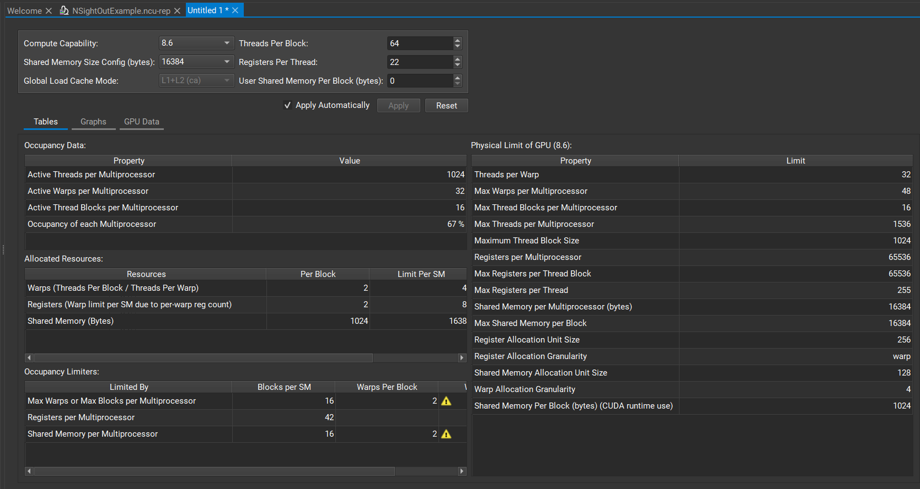
Figure 6: An image taken from NSight Compute’s Occupancy calculator
As seen in Figure 6 in this example the occupancy of the GPU is only 67%. This means that the current version of the application is only utilising that amount of the warps available to it. The main way to improve this number is by changing the number of threads in each thread block. By changing the dimensions of the blocks will change the number of threads running on each multiprocessor and decresing the number of multiprocessors needed and the total time to run the algorithm. On smaller images like the ones being tested in this study the time gained is not big but with images with large resolutions the time gain would be much greater.

Evaluation of Data and Project

Results
When originally making a hypothesis, the prediction was that the GPU will be faster than the CPU when performing mage processing tasks. Using the methods of gathering timing data from the algorithms, the time (in microseconds) was plotted against the image size (in pixels). The resulting three graphs support the hypothesis made as they clearly show a difference between the CPU and CUDA time, with the CPU time being significantly faster.
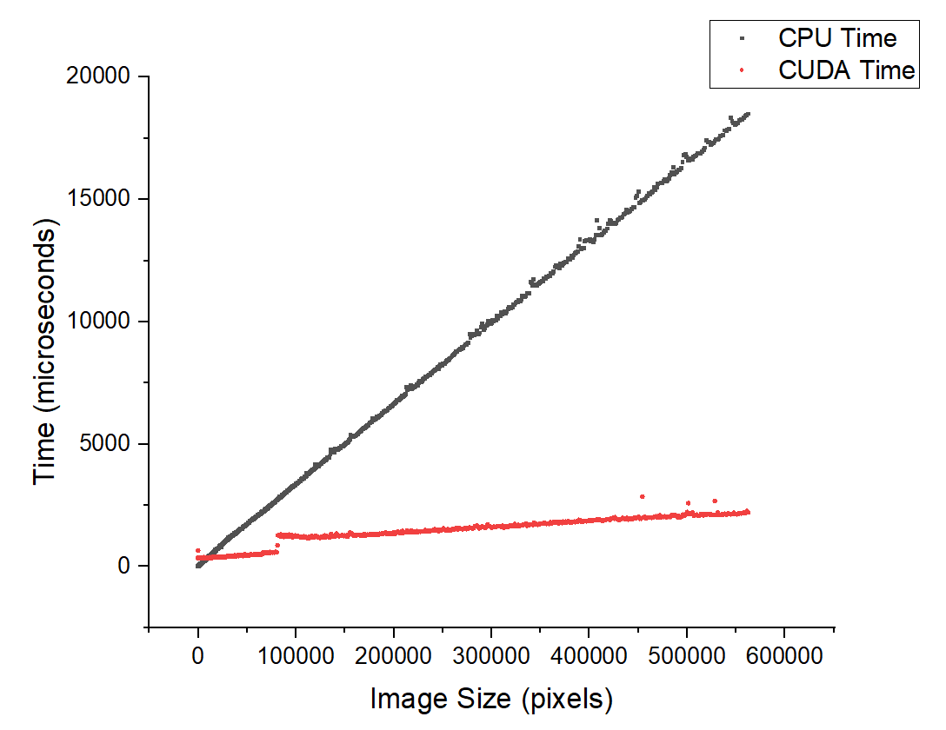
Figure 7: Graph of the timing data collected while running the Sobel Operator with images of size 1 pixel to 562500 pixels
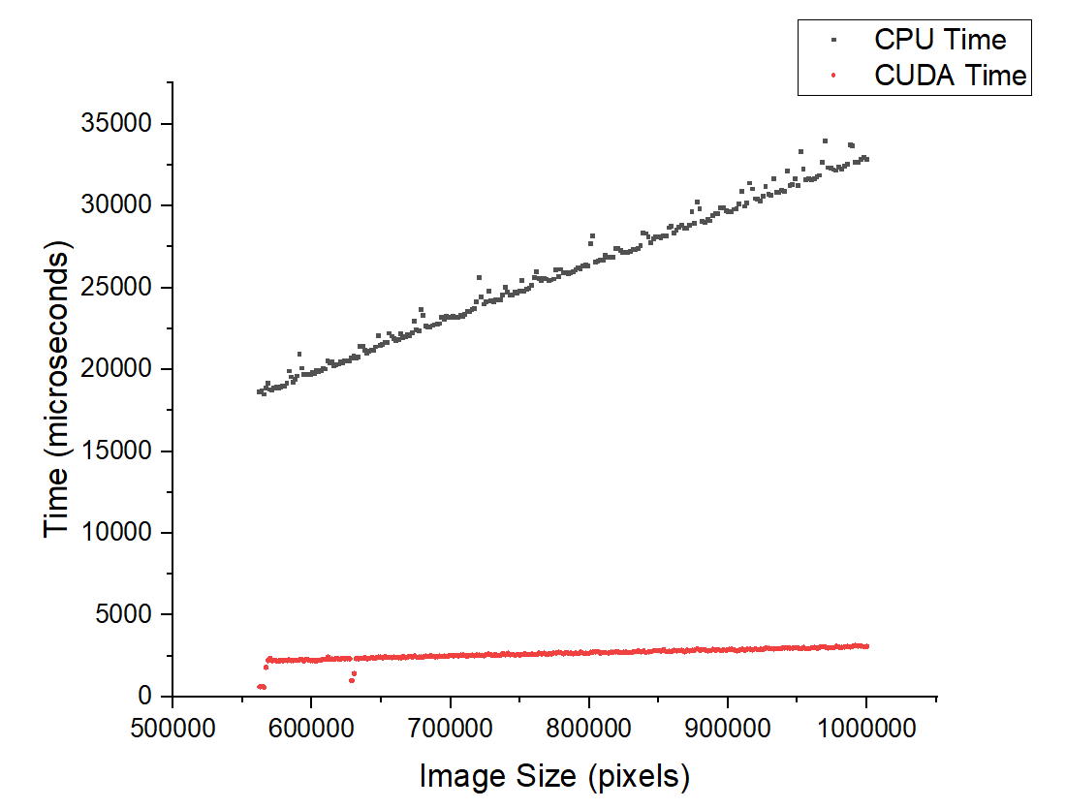
Figure 8: Graph of the timing data collected while running the Sobel Operator with images of size 562500 pixels to 1000000 pixels
As seen in figure 7 and 8 the GPU line is much flatter than the CPU line. This makes sense as the GPU preforms a lot of the computation at the same time unlike the CPU where it all runs sequentially. It is interesting to note the bump in GPU time at around 750000 pixels. At this specific moment, it can be assumed that the GPU runs out of physical threads it can use to compare to the number of pixels in the image. It can be assumed that the GPU reuses multiprocessors that have finish computing to compute the threads still waiting.
Using figure 7 also reveals the crossover point where it is more efficient to use the GPU rather than the CPU. This cross over appear to be at around 10000 pixels. This is an extremely small image meaning the majority of the time using a GPU instead of a CPU would be more time efficient for the Sobel operator.
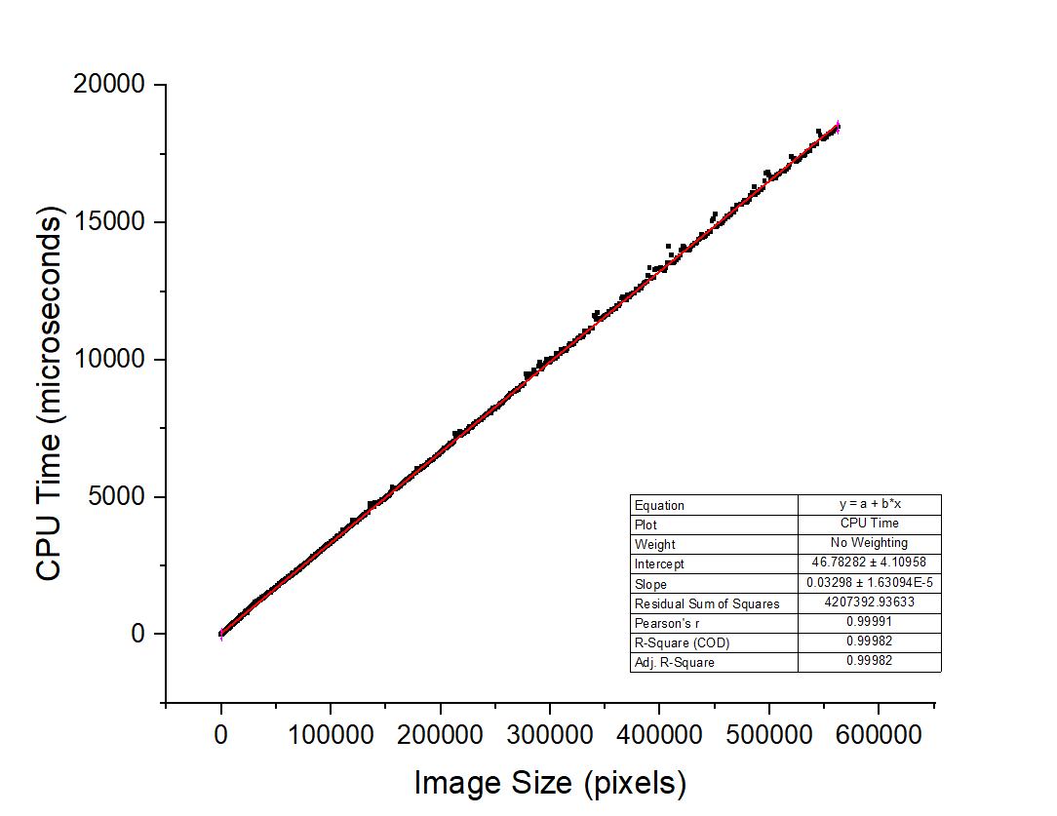
Figure 9: The timing data collected from the Sobel Operator running on the CPU with a line of best fit
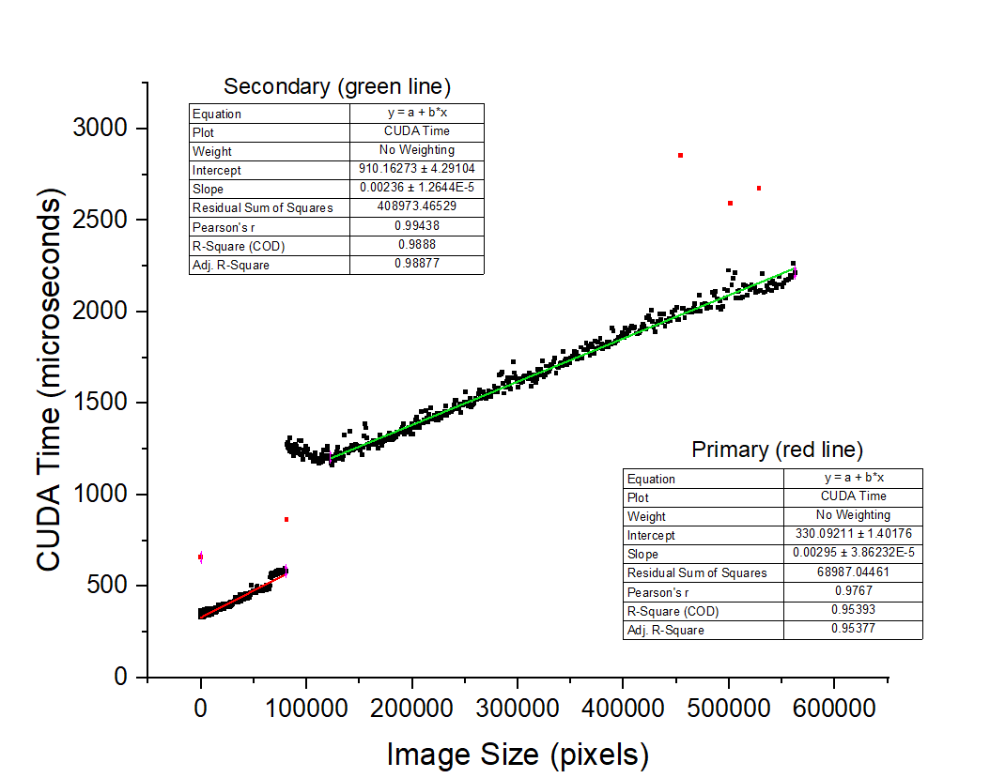
Figure 10: The timing data collected from the Sobel Operator running on the CPU with two lines of best fit (Red marks represent anomalous data)
Figures 9 and 10 show the same data as figure 7 except they are split into CPU and GPU specific graphs. Using these graphs, it is easier to analyse the gradients of the two Sobel implementations. As seen in figure 9, the gradient of the CPU implementation is around 0.03 microseconds per pixel. This is contrasted by figure 10 where the GPU’s gradient was around 0.002 microseconds per pixel. This clearly shows that over time the time disparity between the two implementations will greatly increase as the image size increases. From the graph it can be deducted that the time taken to initiate the CUDA kernel is around the 300 microsecond mark, making it slower than the CPU kernel. This results in the CPU being more time efficient with smaller images.
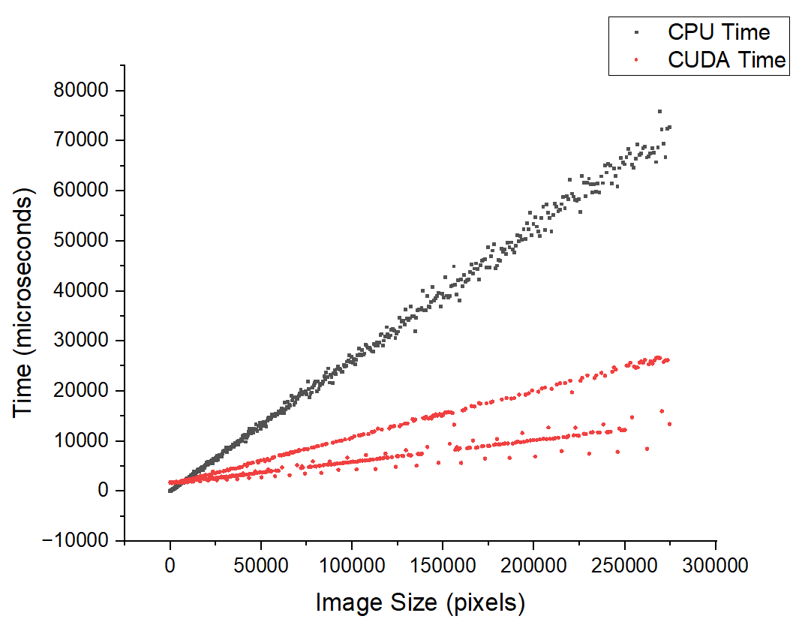
Figure 11: Graph of the timing data collected while running the K-Means algorithm with 5 clusters, 25 iterations and images varying in size from 1 pixel to 274576 pixels
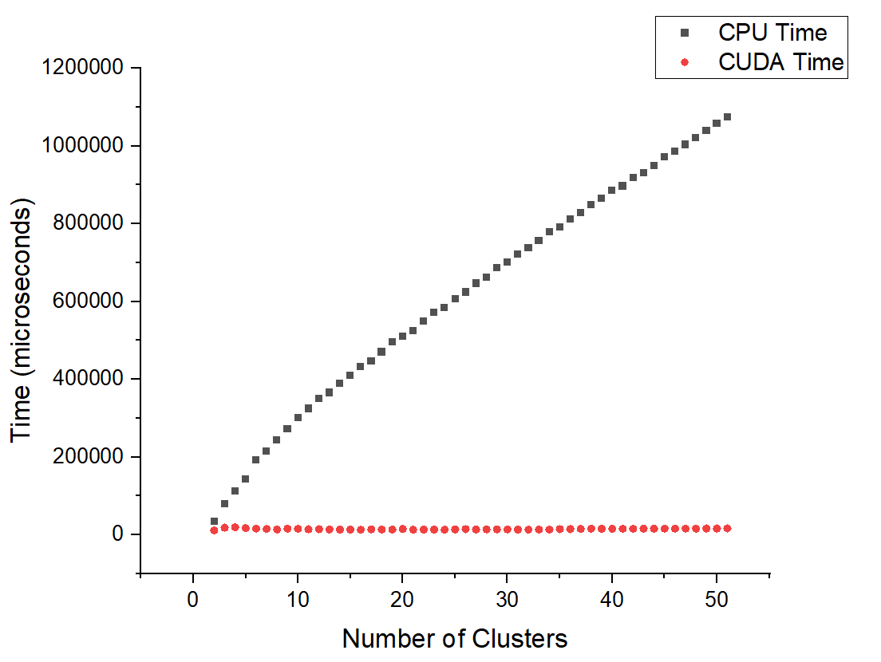
Figure 12: Graph of the timing data collected while running the K-Means algorithm with an image of 750 pixels, 25 iterations and the number of clusters varing from 2 to 51
Figures 11 and 12 show timing data from the implementations of the K-Means algorithm. Figure 11 shows a similar conclusion of figure 7, it can be seen that initially, it is more time efficient to use the CPU for smaller images but with larger images the GPU becomes more efficient. Due to the discrepancies within the GPU data, from an unknown cause, no clear conclusions can be drawn from the CUDA time data from the graph in figure 11.
Figure 12 shows that unlike the CPU, GPU times do not change when the number of clusters changes. This is because the number of clusters never exceeds the number of physical threads on the GPU. It is unlikely that the number of clusters would exceed the number of threads meaning it does not affect the time efficiency.

Project Evaluation
This project has succeeded in creating some data to evaluate the performance differences between CPU and GPU implementations of image processing data. In the grand scheme of the initial objectives set out for the project all objectives have been achieved to varying degrees. Due to the limited time to complete the project compounded with the poor time management some objectives have been attempted with lack lustre success. The original goal was to implement three different image processing techniques compared to the two which were successfully implemented.
The evaluation of CPU and GPU performance was also limited due to two unexpected issues. The first issue was the unexpected issue of using university PCs to preform benchmarks. When originally trying to perform the benchmarks, the executable file created was blocked. This issue was not resolved leading a new solution needing to be found. When downloading the source code from the project repository and trying to compile the program, the compiler returned with errors as the CUDA version on the university machine was not the same as the version on the machine used to produce the code. This issue was resolved late into the process of collecting data meaning no data was collected from hardware other than the machine the code was produced on. The other issue found was the amount of time it takes to run the benchmark. With small images the algorithms took miniscule time to run. As the images increased exponentially so did the time to compute resulting in hours to finish a benchmark with large sizes. Whilst the benchmark was running, the machine used to run it was not used for any other processes or tasks as to not interfere with the benchmark and bias the data. This meant no other work was able to be done reducing productivity.
The issues above meant that the project as a while was not completed to its full extent and capabilities, resulting in some of the findings being shallow and not as in-depth as originally planned to be.

Conclusion
The project had the ability to concluded with a more in-depth result but due to the points raised in section 7.1 the project did not live up to expectations.
The key aspect to improving the project is better planning of the project as a whole, including better time management, alongside the ability to run the program on multiple machines. This would mean that the data would be of a wider range, leading to more reliable results. Another aspect that would have improved the project as a whole would have been checking resources available via the University, which would mean checking the PCs and what version of CUDA they have so as to be able to make the program compatible, leading it to it being able to be run on multiple devices.
Poor time management skills also meant that less research than planned for was conducted, which may have altered the project outcome, so to rectify both issues better time management is needed. Using a more Agile approach to project management with regular reflections and a burn chart would have allowed for better tracking of progress done on the project.
In conclusion, the project could have been handled better resulting in a more in-depth analysis of the research question. However, the project was successful in its own rights and yielded results that are able to be analysed and used to take it further.

References
Singer, G. (2023). The History of the Modern Graphics Processor. Techspot. Available online: https://www.techspot.com/article/650-history-of-the-gpu/ [accessed 10/04/2024].
Niblack, W. (1986). An introduction to digital image processing, Englewood Cliffs, N.J: Prentice-Hall International.
Alvi, F. (2023). Computer Vision and Image Processing: Understanding the Distinction and Interconnection [Blog post]. OpenCV. Dec 13. https://opencv.org/blog/computer-vision-and-image-processing/ (accessed 13/04/2024).
Encyclopaedia of Mathematics. (2011). Edge Detection. Available Online: https://encyclopediaofmath.org/index.php?title=Edge_detection&oldid=17883 [accessed 13/04/2024].
Bhardwaj, S., Mittal, A., (2012). A Survey on Various Edge Detection Techniques. Procedia Technology. 4. 220-226.
Winnemoller, H. & Kyprianidis, J. E., & Olsen, S., C. (2012). XDoG: An eXtended difference-of-Gaussians compendium including advanced image stylization. Computer &Graphics. 36(6). 740-753.
Ghorpade, J. & Parande, J. & Kulkarni, M. & Bawaskar, A. (2012). GPGPU Processing in CUDA Architecture. Advanced Computing: an International Journal. 3(1), 105-120.
Janik, A. (2020). ZLUDA. Available online: https://github.com/vosen/ZLUDA [accessed 17/04/2024].
Dhanachandra, N. & Manglem, K. & Chanu, Y., J. (2015). Image Segmentation Using K -means Clustering Algorithm and Subtractive Clustering Algorithm. Procedia Computer Science. 54. 764-771.
Nvidia. (2024). CUDA C++ Programming Guide. Available online: https://docs.nvidia.com/cuda/cuda-c-programming-guide/index.html [accessed 17/04/2024].
OpenCV. (2024). OpenCV Open Computer Vision Library. Available online: https://opencv.org/ [accessed 17/0402024].
Tschumperlé, D. (2004). The CImg Library. Available online: https://www.cimg.eu/ [accessed 17/04/2024].

